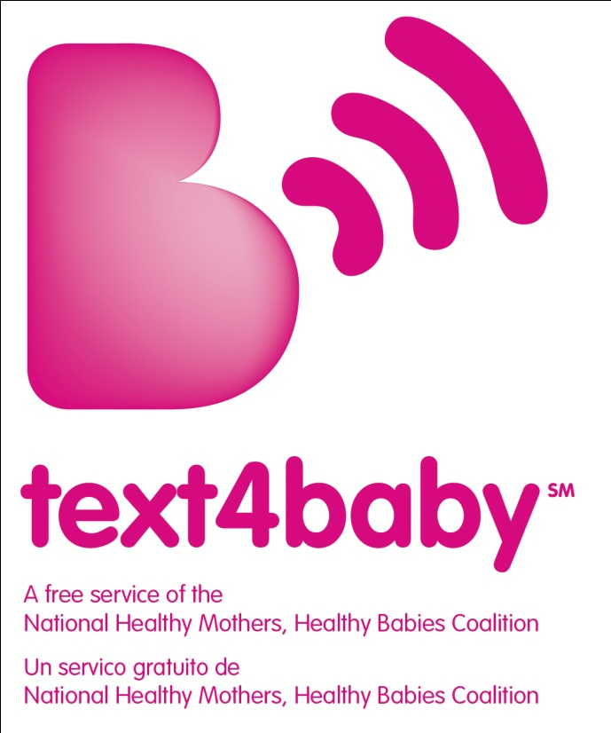

Text4baby Toolkit Templates
For employers—Customizable templates to help you communicate to your employees and their families

Table of contents
Sample communication templates and how to use them 3
Sample program information sheet 4
Sample benefits guide content 6
Sample newsletter/intranet article 7
Sample benefits/hr email signature tagline 8
Sample wallet card 8
Sample Tweet 8
FAQs for employees and participants 9
Using text4baby 9
Troubleshooting 11
About this toolkit 12
Legal disclaimer 12

Sample communication templates and how to use them
Customizable benefits communication templates
To help get you started in promoting text4baby to your employees and their families, the following pages include sample templates, provided in Microsoft Word. You can easily customize these templates to coordinate with your company’s benefits communications.
- Sample program information sheet
- Sample benefits guide content
- Sample newsletter/intranet article
- Sample benefits/HR email signature tagline
- Sample wallet card
- Sample Tweet
- FAQs for employees and participants
How to use these customizable communications
- Include program information sheet and wallet card in materials sent to pregnant employees and employees with newborns.
- Provide program information sheet, FAQs and sample newsletter/intranet article to your employer-sponsored carriers/vendors of prenatal and postpartum care, educational classes and condition-management programs. Ensure that content is included in prenatal care education programs.
- Include text4baby benefits guide content in open enrollment materials, such as benefits guide, newsletters or presentations.
- Provide employees with text4baby program information sheet and wallet card at health fairs and open enrollment meetings.
- Provide program information sheet to clinicians at on-site medical facilities to distribute to employees.
- Add the benefits/HR email signature to emails.
Sample program information sheet
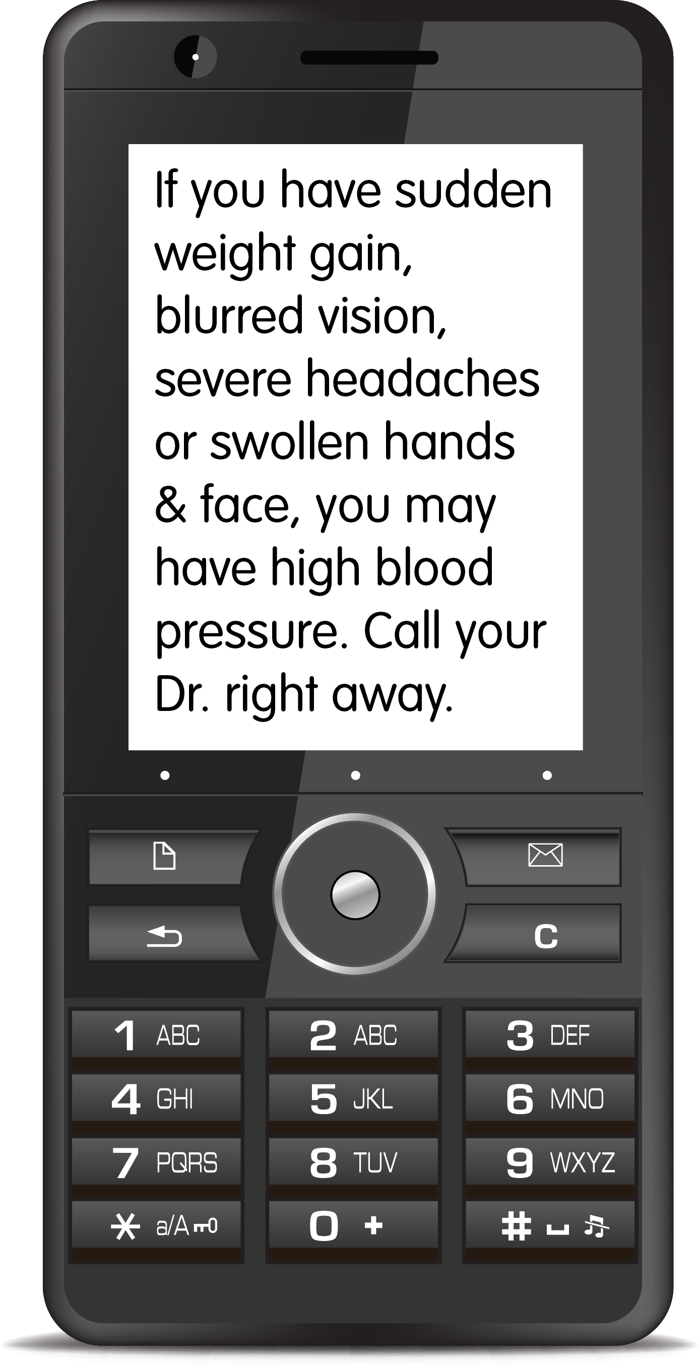
Use this content to design and print an information sheet for employees.
New Moms and Moms-to-Be:
You’re tired, beyond busy and juggling a lot …
Sign up for text4baby! It’s a free way to get helpful text-message tips, reminders, resources and alerts about pregnancy and infant care during your pregnancy and until your baby’s first birthday. (Available in English or Spanish.)
It’s free. Really! Even if you don’t have a text-messaging plan on your cell phone, you can receive these texts for free. And if your cell plan has a limited number of texts per month, text4baby messages won’t count toward the limit.
Messages are free as long as you are using one of the following participating carriers:

Alltel
Assurance Wireless
AT&T
Bluegrass Cellular
Boost Mobile
Cellular South
Cellcom
Centennial Wireless
Cincinnati Bell
Cricket
MetroPCS
n-Telos
Nex-Tech Wireless
Sprint Nextel
T-Mobile
U.S. Cellular
Verizon Wireless
Virgin Mobile USA

Registration takes only seconds—Simply text the word BABY (for English texts) or the word BEBE (for Spanish texts) to 511411. Then enter your baby’s due date or birthday and your ZIP code. That’s it! You will never be asked to provide personal information, and you will never be sent ads.
Once enrolled, you’ll begin receiving three short text messages per week—timed to your due date or your baby’s birthday—until your baby is one year old. You can cancel the service at any time by texting STOP to 511411.
Why was text4baby created?
Text4baby was created to provide pregnant women and moms of babies with critical information on caring for their health and giving their babies the best possible start in life. Launched by the National Healthy Mothers, Healthy Babies Coalition (HMHB), text4baby is made possible through a broad, public–private partnership that includes mobile phone companies, government agencies, businesses, academic institutions, professional associations and nonprofit organizations.

Here’s a sample of the free text messages you’ll get.
Need help paying for visits to the Dr. or midwife? Call your health plan to learn about your benefits. Or call Medicaid for help: 877-543-7669.
Diabetes can happen for the 1st time in pregnancy. You may be tested at 24-28 weeks. If you have it, you & your Dr. will make a plan to control it.
If you have any signs of preterm labor--cramps, belly tightening, low back pain, bleeding, or watery, pink/brown discharge--call your Dr. right away.
Going to need child care? Ask your employer about resources. Or call Child Care Aware at 800-424-2246 for info on locating care & help with costs.
The safest way for baby to sleep is on his back in a crib near your bed (within arm's reach).
Give your baby a taste for healthy foods from the start! If you need help buying food for your child, call 800-311-2229 to connect to WIC.
Sign up today and start receiving practical, supportive text messages during this important time of your life. Share the knowledge! Tell your pregnant friends and moms with babies about text4baby or forward texts to them.
Reminders. Take advantage of the other programs and services [Company name] provides to help you during and after pregnancy. And after your baby is born, you need to enroll him or her on your health plan within 30 days. Go to [include benefits URL]. Remember, when you use network providers, preventive care is covered at 100%—this includes well-baby visits and immunizations.

Sample benefits guide content

Resources for moms-to-be and moms of babies
Take advantage of the variety of resources available to help you have a healthy pregnancy and give your baby a healthy start in life.

Text4baby is a free text-messaging service (in English or Spanish) with practical tips, reminders, resources and alerts about pregnancy and infant care. Sign up by texting BABY (or BEBE for Spanish) to 511411. Enter your due date or baby’s birthday and your zip code. (You will never provide personal information or receive ads.) You can also get more info and sign up for the service online at www.text4baby.org.
A program of the National Healthy Mothers, Healthy Babies Coalition (HMHB), text4baby is made possible through a broad public–private partnership. You’ll get three informative texts a week during your pregnancy and until your baby’s first birthday.
Whether this is your first pregnancy or you’re a veteran mom, text4baby messages provide education and helpful reminders about important medical milestones for you and your baby. During this time of your life, you can probably use a few helpful reminders. Try it out. It’s free, and you can stop it at any time. Be sure to tell your friends about it.
Note: Text4baby is free for customers of participating mobile carriers; all major U.S. carriers participate.

[Insert other maternity programs offered by your health plans and EAP.]

Don’t forget to enroll baby for benefits. After your baby is born, you need to enroll him or her on your health plan within 30 days. For more information, see [insert URL to qualifying life events section of benefits website or the eligibility page in the benefits guide].

Get preventive care—it’s free! Remember, when you use network providers, preventive care—including well-baby visits and immunizations—is covered at 100%. Learn about the preventive care services available to you and your family by visiting [insert URL to the preventive services section of the benefits website] or see page [insert preventive benefits page of the benefits guide] of the benefits guide.
Sample newsletter/intranet article

Text4baby cuts through the noise
If you're pregnant or the mom of a baby, you know how easy it is to get overwhelmed by information on everything from nutrition to breastfeeding to choosing childcare. It’s easy to get lost in the deluge of pregnancy books, articles, websites and advice from everyone. And it’s hard to prioritize what information is most critical and when.
A free text-messaging service for pregnant women and moms of babies is cutting through the clutter and delivering the right information at the right time in your pregnancy or baby’s first year. Launched in 2010 by the National Healthy Mothers, Healthy Babies Coalition (HMHB), through a broad, public–private partnership, text4baby provides short, actionable tips and resources in English or Spanish. First-time moms learn new information, and veteran moms get useful reminders about important medical milestones of pregnancy and early child development and care. And with its real-time format, text4baby communicates critical alerts as they occur, on topics such as car-seat positioning, product recalls and safety warnings, and regional wellness outbreaks.
To sign up, text the word BABY to 511411. For Spanish, text BEBE to 511411. Or visit www.text4baby.org. You will never provide personal information, and you will never receive ads.
Take advantage of these other programs and services [Company name] provides to help you during and after pregnancy. [Insert programs such as Healthy Baby that are offered by your health plans and EAPs.]
Don’t forget to enroll baby for benefits. After your baby is born, you need to enroll him or her on your health plan within 30 days. For more information, see [insert URL to qualifying life events section of the benefits website or the eligibility page in the benefits guide].

Get preventive care—it’s free! Remember, when you use network providers, preventive care is covered at 100%—this includes well-baby visits and immunizations. Learn about the preventive care services available to you and your family by visiting [insert URL to the preventive services section of the benefits website] or see page [insert preventive benefits page of the benefits guide].

Note: Text4baby is free as long as you use one of these participating carriers:
Alltel
Assurance Wireless
AT&T
Bluegrass Cellular
Boost Mobile
Cellular South
Cellcom
Centennial Wireless
Cincinnati Bell
Cricket
MetroPCS
n-Telos
Nex-Tech Wireless
Sprint Nextel
T-Mobile
U.S. Cellular
Verizon Wireless
Virgin Mobile USA
Sample benefits/hr email signature tagline

Text4baby: Help pregnant women and new moms get information about caring for their health and giving their babies the best possible start in life. It’s free! Text BABY to 511411. For Spanish, text BEBE to 511411. www.text4baby.org Pass it on ….

SAMPLE WALLET CARD
Use this content to design and print a wallet card to distribute to employees.
[front of card]
Health Tips 4 Mom and Mom 2B
Sign up for text4baby and pass this card on.
Text BABY to 511411 (or BEBE for Spanish). Enter your due date or baby’s birthday and your zip code. (You will never provide personal information or receive ads.)
You’ll get free texts with practical tips, reminders, resources and alerts about pregnancy and infant care for baby’s first year.
[back of card]
A program of the National Healthy Mothers, Healthy Babies Coalition (HMHB), text4baby is made possible through a broad public–private partnership. Get more info at www.text4baby.org.
Text4baby is free for customers of participating mobile carriers; all major U.S. carriers participate.

Go to [include Company benefits site URL] to learn about all the maternity and preventive care benefits available to you through [Company name].

SAMPLE TWEET
Moms-to-be & moms of babies: Free pregnancy & infant care tips. Text BABY (BEBE for Spanish) to 511411. Non-profit www.text4baby.org. Pass it on!

FAQs for employees and participants

You’ll find FAQs grouped by the following areas:
- Using text4baby
- Troubleshooting
Using text4baby
Q: You say that this service is free. Is that really true?
A: Yes. Thanks to the support of CTIA-The Wireless Foundation (http://www.text4baby.org/index.php/get-involved-pg/102) and participating mobile operators, all messages you receive from text4baby are free! Subscribers without a text-messaging plan still receive the texts for free, and text4baby messages don’t count toward monthly limits for users with limited texting plans. View the full list of participating operators at http://www.text4baby.org/index.php/get-involved-pg/8-about-us/1.
Q: Are the text messages free for people who have pay-as-you-go or pre-paid cell phones?
A: Yes, as long as you have service with one of the text4baby mobile operator partners (http://www.text4baby.org/index.php/get-involved-pg/8-about-us/1), you will be able to get the messages for free.
Q: Is this service available to every mobile phone subscriber in the United States?
A: The majority, though not all, mobile carriers are providing this service. It is available
to more than 96% of people with cell phones. You can find the full list of participating carriers at http://www.text4baby.org/index.php/get-involved-pg/8-about-us/1. Every effort has been made to block service from non-participating carriers, but if you find you have been able to access the service and have been charged, please contact your wireless provider right away.
Q: How many messages will I receive each week?
A: You will receive approximately three messages per week on your cell phone. Urgent alerts or breaking news might mean you see a few additional messages once in a while.
Q: Are the messages personalized?
A: The text4baby messages are not personalized, but the information in each message is relevant to where you are in your pregnancy or what your baby is going through at particular stages of development. You can learn more about the text4baby messages at http://www.text4baby.org/index.php/get-involved-pg/8-about-us/87.
Q: Can I write back with questions?
A: Text4baby is a one-way educational program, so you can’t text questions or communicate back with the program. However, if you have specific questions, you can call the phone numbers you find in the messages (http://www.text4baby.org/index.php/get-involved-pg/2-uncategorised/79). You can also ask your doctor, midwife, nurse or other health care provider.
Q: What if my due date changes?
A: If your due date changes, text the word UPDATE to 511411. You will be asked for the new due date, and then the messages you receive will be adjusted to that new date.
Q: What if I deliver my baby early?
A: If you deliver your baby early, you can update by texting UPDATE to 511411. You will then be prompted to text in your baby’s actual birthday, and messages will be adjusted.
Q: If I sign up when I’m pregnant, will I still get the messages once I deliver my baby?
A: To continue getting text4baby messages once your baby is born, just text UPDATE to 511411 and respond with the baby’s actual birth date. You’ll receive messages until your baby’s first birthday.
Q: I’m already enrolled in text4baby for my infant, but I’m pregnant again. How can I get both kinds of messages?
A: At this time, you can only be enrolled to get the pregnancy messages or the infant messages, but not both. Try asking a friend or family member to sign up on their phone for the other messages, so you can read both!
Q: How long will I receive text messages?
A: The messages will continue throughout your pregnancy and your baby’s first year.
Q: Can I forward the messages to my friends?
A: Yes. We encourage you to share the messages with friends and family. Tell them to sign up, too!
Q: How do I stop getting the messages?
A: To stop receiving texts from the text4baby service, you simply text STOP to 511411. (Please do not email.)
Q: How do I sign up for Spanish messages instead of English?
A: You can sign up for text4baby in Spanish by texting BEBE to 511411. You can sign up for text4baby in English by texting BABY to 511411.
Q: What information will I have to provide to sign up?
A: The text4baby service collects your phone number, zip code and your due date or baby’s birth date. This information is used to provide the messaging service and not for any commercial purposes.
Q: What will happen with my personal information?
A: Information collected from you during registration is used solely to enroll you in the text4baby service, allowing you to receive the text messages. Your information is not sold
or shared with anyone. Review the text4baby privacy policy at http://www.text4baby.org/index.php/privacy-policy.
Q: Can anyone sign up for text4baby?
A: Yes. While the messages are written for pregnant women and moms of infants, anyone can sign up and use the messages.
Q: Will I get messages with local information?
A: Text4baby is currently a national program, so the information provided refers to nationally available resources. When you call the phone numbers in the text messages (http://www.text4baby.org/index.php/get-involved-pg/2-uncategorised/79), you will be connected to local resources.
Troubleshooting
Q: I am trying to sign up for text4baby, and it won’t work. Why not?
A: The service is blocked on phones that do not have service with one of the participating mobile operators. If you do have service with a participating carrier and text registration (BABY to 511411) is not working, please try registering online by going to http://www.text4baby.org/index.php/sign-up. If you are familiar with mobile operators who are not currently participating in text4baby, please email info@text4baby.org.
Q: I lost my cell phone. What should I do?
A: If you have a new cell phone with a different number, you will need to sign up again by texting BABY or BEBE to 511411.
Q: I changed cell phone numbers. What should I do?
A: If you have a different phone number, you will need to sign up again by texting BABY or BEBE to 511411.
Q: I am trying to sign up, but it says I am already registered. What should I do?
A: Text the word UPDATE to 511411 (or just reply to the last text4baby message you received). You will be able to enter the correct due date or birth date for your baby. If this doesn’t work, try texting in STOP to 511411, wait one day, and sign up again by texting BABY (or BEBE) to 511411.
Q: This has been promoted as a free service, but I think I may have been charged by my carrier. What should I do?
A: Thanks to the support of CTIA-The Wireless Foundation and participating wireless service providers, all messages you receive from text4baby are free. If you suspect you may have been charged for messages to and from the service, please call your wireless provider right away. They will give you a refund if you have been charged for the service by mistake.
About this toolkit

This Toolkit and Templates were created pro bono by Benz Communications, a text4baby outreach partner, in collaboration with the National Healthy Mothers, Healthy Babies Coalition.
Benz Communications is a leading benefits and HR communication firm and creates solutions to help companies make their benefits—and benefits communication—more effective. Visit us on the web at www.benzcommunications.com.
Feedback? Questions? We’d love to hear from you! Contact text4baby at info@text4baby.org.

Legal disclaimer
These materials represent best practices and are marketing materials intended to help employees understand, appreciate and use employee benefit programs. The materials are not intended to be legal plan documents and are not intended to satisfy the client’s legal requirements regarding employee communications.

The materials are provided on an “as is” basis, without warranties of any kind. Benz Communications and text4baby expressly disclaim any and all representations and warranties, including without limitation the implied warranties of merchantability, fitness for a particular purpose and non-infringement.

Benz Communications makes no representation, warranty or guarantee as to the content, accuracy or completeness of the materials, or that the materials will be error-free or will comply with any legal or regulatory requirements to which the client is subject. The user of these materials expressly agrees that its use of the materials is at its sole risk, and that it assumes full responsibility for all risks associated with its use of the materials.

© Copyright 2012 Benz Communications.

